Scout Master’s Registration eg]{ tl/sf

Step 1: of] URL: https://admin.nepalscouts.org/scout/master/create df click ug'{xf]nf .

Step 2: dflysf] URL click u/] kZrft lgDglnlvt ljj/0fx? cfpg] 5g\ . pQm site df b]lvP cg';f/sf] ljj/0fx? eg'{ xf]nf .

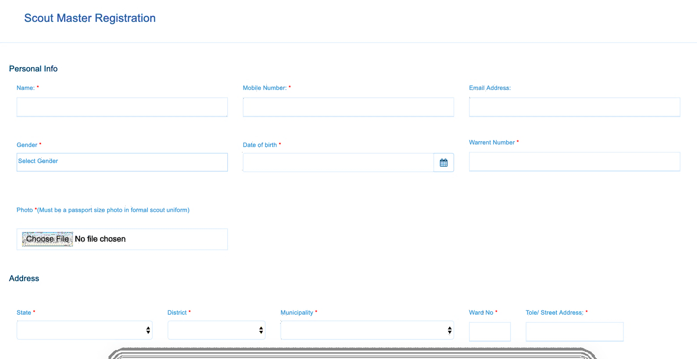
Photo should be as follows:
(In full Scout Uniform, Half Photo, No Selfy Photo)
lnË
k'/f gfd / y/
df]afO{n g+=
hGdldlt
lh=:sf=sf af6 hf/L ul/Psf]
clwsf/ kq
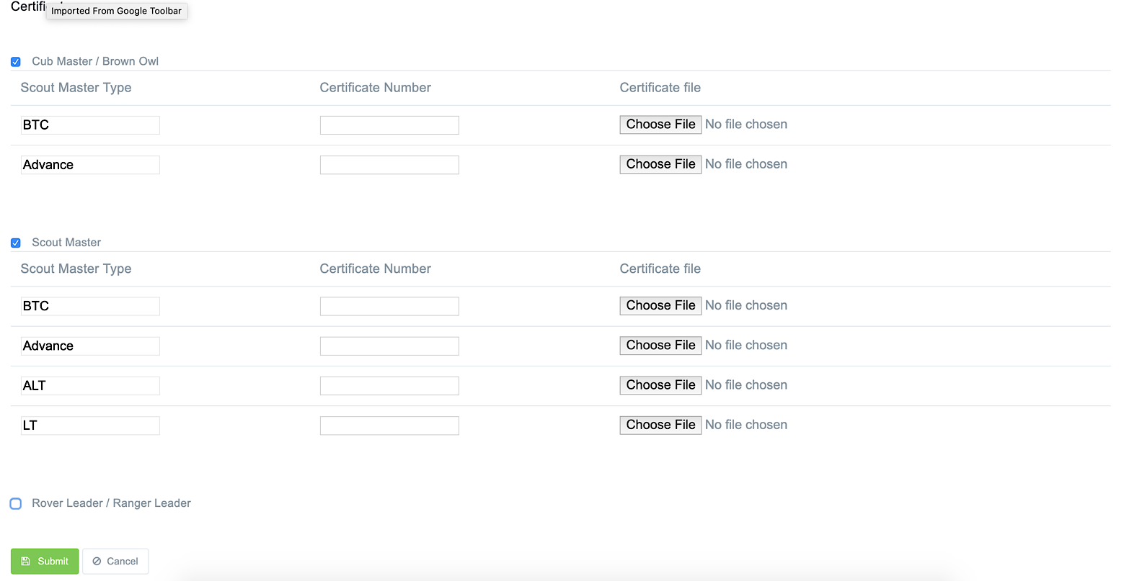
Hf:t}: 210-324/076
k|df0f kq upload ug]{

Step 3: dflysf] ;a} ljj/0fx? e/] kZrft dfq Submit df click ug'{xf]nf .

