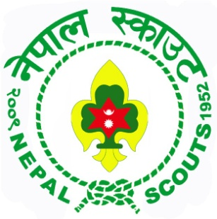
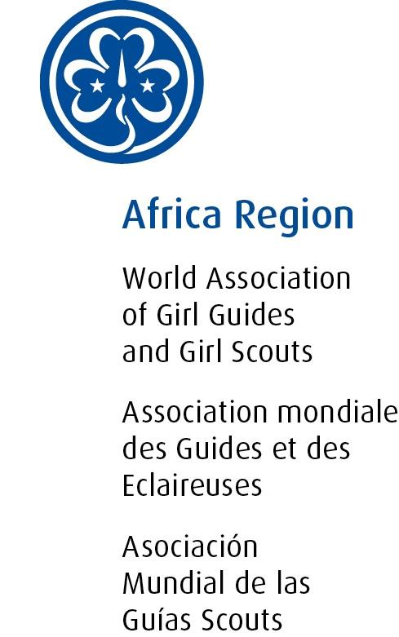
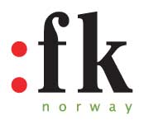

YESS girls movement 2020: APPLICATION FORM

READ CAREFULLY THE CRITERIA OF SELECTION AND INSTRUCTIONS BELOW:

- Be an active girl guide between 18 – 24 years old
- Be available from 1st January to 30th September 2020
- This form is open from 3 October- 13 October 2020
- Fill out sections 1 – 4 ONLY
- Type your responses with your computer or handwrite in BLOCK letters
- Section 5 must be signed by your District Commissioner
- Section 6 must be signed by your Parent/Guardian
- Send back your filled form on info@nepalscouts.org and copy on saaaaaru988640@gmail.com not later than 13 October, 2020
- Bear in mind that this opportunity is equal to all girl guides, and the selection process will treat fairly all candidates.

SECTION 1 – PERSONAL DETAILS

First/Given name: ------------------------------------------------------------------------------------------

Middle name: ------------------------------------------------------------------------------------------------

Surname/Family name: ----------------------------------------------------------------------------------

Date of Birth (Day/Month/Year): ---------/-----------/-----------

Place of birth (city and country): ----------------------------------------------------------------------

Level of Education: ----------------------------------------------------------------------------------------

ADDRESS

City/Village: ---------------------------------------------- Cell: --------------------------------------------

District: ---------------------------------------------- Province: -------------------------------------------

Mobile: --------------------------------------------------- Email: --------------------------------------------

Do you own a valid passport? : YES NO

If yes:
Passport number:
Passport issue date:
Passport expiry date:

If no:
Expected issue date:

LANGUAGES SPOKEN:

Language | Fluent | Intermediate | Basic
English
French
Other

T-shirt size: S L XL XXL

Internet access level: High Medium Low

EMERGENCY CONTACT (Give the contact of your parent/ guardian)

Names: ---------------------------------------------------------------------------------------------------------

Relationship to you: ---------------------------------------------------------------------------------------

Address: District ----------------------------------------- Province ------------------------------------

Mobile: --------------------------------------------------- Email: --------------------------------------------

SECTION 2 – GIRL SCOUTING BACKGROUND

Your current position in Girl Scouting (Guiding):

---------------------------------------------------------------------------------------------------------------------

National events attended during the past three years:

---------------------------------------------------------------------------------------------------------------------------------------------------------------------------------------------------------------------------------------------------------------------------------------------------------------------------------------------------------------------------------------------------------------------------------------------------------------------------------------------------------------------------------------------------------------------------------------------------------

WAGGGS activities attended during the past three years:

---------------------------------------------------------------------------------------------------------------------------------------------------------------------------------------------------------------------------------------------------------------------------------------------------------------------------------------------------------------------------------------------------------------------------------------------------------------------------------------------------------------------------------------------------------------------------------------------------------

Education: Give a short statement of qualifications gained which are relevant to Girl Scouting (Guiding)/the work of WAGGGS:

---------------------------------------------------------------------------------------------------------------------------------------------------------------------------------------------------------------------------------------------------------------------------------------------------------------------------------------------------------------------------------------------------------------------------------------------------------------------------------------------------------------------------------------------------------------------------------------------------------

Have you done any scouting (guiding) work that involved people from other countries than Nepal? If yes, give details

---------------------------------------------------------------------------------------------------------------------------------------------------------------------------------------------------------------------------------------------------------------------------------------------------------------------------------------------------------------------------------------------------------------------------------------------------------------------------------------------------------------------------------------------------------------------------------------------------------

SECTION 3 – YESS GIRLS MOVEMENT 2020

Why are you interested in YESS Girls Movement? What qualifies you as a good candidate?

---------------------------------------------------------------------------------------------------------------------------------------------------------------------------------------------------------------------------------------------------------------------------------------------------------------------------------------------------------------------------------------------------------------------------------------------------------------------------------------------------------------------------------------------------------------------------------------------------------
---------------------------------------------------------------------------------------------------------------------------------------------------------------------------------------------------------------------------------------------------------------------------------------------------------------------------------------------------------------------------------------------------------------------------------------------------------------------------------------------------------------------------------------------------------------------------------------------------------

What relevant skills and experience could you bring to the hosting association and other participants?

---------------------------------------------------------------------------------------------------------------------------------------------------------------------------------------------------------------------------------------------------------------------------------------------------------------------------------------------------------------------------------------------------------------------------------------------------------------------------------------------------------------------------------------------------------------------------------------------------------
---------------------------------------------------------------------------------------------------------------------------------------------------------------------------------------------------------------------------------------------------------------------------------------------------------------------------------------------------------------------------------------------------------------------------------------------------------------------------------------------------------------------------------------------------------------------------------------------------------

Choose a country you would like to work in:

- Ghana
- Uganda

Motivation of your choice:

------------------------------------------------------------------------------------------------------------------------------------------------------------------------------------------------------------------------------------------
---------------------------------------------------------------------------------------------------------------------
How will you use your skills and expertise in the hosting organization during the programme?

---------------------------------------------------------------------------------------------------------------------------------------------------------------------------------------------------------------------------------------------------------------------------------------------------------------------------------------------------------------------------------------------------------------------------------------------------------------------------------------------------------------------------------------------------------------------------------------------------------
---------------------------------------------------------------------------------------------------------------------------------------------------------------------------------------------------------------------------------------------------------------------------------------------------------------------------------------------------------------------------------------------------------------------------------------------------------------------------------------------------------------------------------------------------------------------------------------------------------
---------------------------------------------------------------------------------------------------------------------------------------------------------------------------------------------------------------------------------------------------------------------------------------------------------------------------------------------------------------------------------------------------------------------------------------------------------------------------------------------------------------------------------------------------------------------------------------------------------

How will you use the skills, knowledge and experiences gained at the completion of the programme, especially at the benefit of Girl Scouting (Guiding) in Nepal?

---------------------------------------------------------------------------------------------------------------------------------------------------------------------------------------------------------------------------------------------------------------------------------------------------------------------------------------------------------------------------------------------------------------------------------------------------------------------------------------------------------------------------------------------------------------------------------------------------------
---------------------------------------------------------------------------------------------------------------------------------------------------------------------------------------------------------------------------------------------------------------------------------------------------------------------------------------------------------------------------------------------------------------------------------------------------------------------------------------------------------------------------------------------------------------------------------------------------------
---------------------------------------------------------------------------------------------------------------------------------------------------------------------------------------------------------------------------------------------------------------------------------------------------------------------------------------------------------------------------------------------------------------------------------------------------------------------------------------------------------------------------------------------------------------------------------------------------------
---------------------------------------------------------------------------------------------------------------------------------------------------------------------------------------------------------------------------------------------------------------------------------------------------------------------------------------------------------------
SECTION 4–APPLICANT CONSENT

By signing this form, I understand/ agree that:

- My information will be kept in the database of Nepal Scouts and WAGGGS and will be used for the purpose of the selection process
- Photos taken during the programme can be published by AGR or WAGGGS in publication, media and promotional material
- I am fully available for a duration of eight months, from 1st January to 30 September 2020
- I talked this programme to my parents/ guardians, made them sign the consent form, and agreed to receive AGR YESS team for a visit
- My commitment to fully dedicate the best of my abilities to the hosting organization
- My commitment to serve Nepal Scouts for Two Months, full time at the end of the programme
- Failure to respect rules of YESS programme may result to other decisions from Nepal Scouts or hosting organization.

Names of applicant: (IN BLOCK LETTERS)

---------------------------------------------------------------------------------------------------------------------

Signature: -------------------------------------------- Date: ------------------------------------

SECTION 5: DISTRICT COMMISSIONER CONFIRMATION

I confirm this nomination on behalf of my district and I agree to provide my full support to this candidate upon her return home.

Name of District Commissioner:

---------------------------------------------------------------------------------------------------------------------

Mobile: ------------------------------------------ Email Address: ----------------------------------------

Signature: -------------------------------------------- Date: ------------------------------------

SECTION 6: PARENT/ GUARDIAN CONSENT AND CONFIRMATION

By signing this form I understand:
- I understand YESS Girls Movement and its benefits on my child personal growth
- I agree that she has no other commitment from 1st January - 30 September 2020
- I approve her stay abroad for six months as representative of all girl scouts of Nepal
- I accept her service to Nepal Scouts upon return home, for duration of Two Months in the implementation of learnt skills and knowledge.

If my child is selected, I would like further information about YESS Girls Movement
YES NO

I would like Nepal Scouts team to pay me a visit:
YES NO

If yes, preferred day and hour: -------------------------------------------------------------------------

Names of parent/ guardian: (IN BLOCK LETTERS)

---------------------------------------------------------------------------------------------------------------------

Signature: -------------------------------------------- Date: ------------------------------------

